If I had a $1 billion dollar dream home
Jordan Hinrichsen
Miss. Killoh
Wellness 10
May 7, 2014

$1 Billion Dollar Dream Home
How do you know you have too much money? When you have a 27- story custom- built home, but you don/t actually live there. Instead, you choose to live in your 14-story apartment tower.
53- year old Mukesh Ambani is the billionaire chariman of reliance Industries, and the fourth richest man in the world. His home in Mumbai, India which is called Antilia- has an estimated worth of $1 billion and is the most expensive house in the world. Complete with six floors of parking space (home of Ambani’s extensive car collection), a health spa, a snow room, three helipads, a 50- seat movie theatre, multiple swimming pools,a dance stidio and a series of floating and haning gardens, it takes 600 employees just to operate the home.
But apparently it’s all for naught, because the Ambanis don’t live there.
There are all sorts of theories as to why the Ambani’s haven’t moved in yet. Some say that the home doesn’t meet the requirements of Vastu Shatra, an anciet Indian architectural doctrine. According to the New York Times, Vastu expert Bassannt R. Rasiwasia, says that there are not enough windows on the eastern side of the house, and too many on the west-facing side. “ This always leads to misunderstanding between team members or sometime may create issues,” he says. “This also indicates more hard work to achive moderate success. There is more negative energy coming from the western side.”
Others speculate that criticism from Mumbai residents could also be the problem. Most Mumbai residents live on less than $2 a day, and more than half of them live in slums – slums than can be seen from the towering building’s windows. Ambani and his wife, Nita – a philanthropist who is actively involved in areas of education, disaster relief and human resources – are reportedly upset by these sentiments. It is thought by some that this criticism could have influenced them to stay where they are.
Still others say that the Ambanis don’t live there because the house is not a home –and no wonder. While no floor is alike, each is designed to flow architecturally from one room to another to create consistency. To avoid repetition, each floor is made with different materials. Although this all sounds, I imagine that it’s hard to feel at home. The building is 550- feet high, after all, and built on 49,000 square feet. Losing one another would certainly be easier than finding one another. I imagine that the entire Ambani family- husband, wife and 3 children- would feel very much alone in such an extravagant and overwhelming large space.
So now what will they do with it? Who can afford to buy a $1 billion home? Better, what on earth are they going to do with it?
The family should try to sell the house by half the estimated cost so that they could get half their money back. Also even though they don’t live there it has a high cost of maintence, with hundreds of employees. Which is a lot of money to spend for a house nobody uses.
I would not purchase the home, because I would not want to live in India, since it’s very hot there and there’s a lot of poverty. Also you can get very big mansions for only a couple million, which would be cheaper and more functional. With all the money that you save from buying a smaller house you could buy probably buy that pure gold suit that you always wished for.
If I had to design a billion dollar house, it would be built in Southern Ontario by Ottawa or Toronto. It would be a four story home with many acres of land. On those acres of land of would many things such as a two story garage, and small lake of water that would be filled with all kinds of fish. It would also have many courts for basketball and tennis. In the garage that I have, it will have a very expensive car collection and one minivan, just because I can.

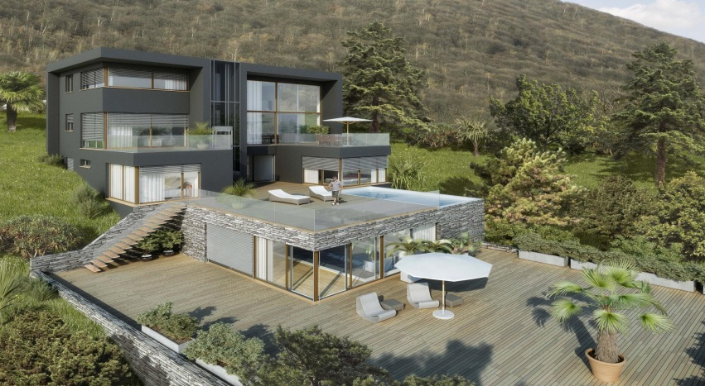

Works Cited
Epp, Melanie. “The world’s most expensive house is everything but home.” YourMoney.ca. 26 OCT 2011. Web. 26 Oct 2011. <http://realestate.yourmoney.ca/2011/10/billion-dollar-house-is-everything-but-home.html>

